**Process Document**

**Formatting focal dataset:**

* **Dataset name**: Capital_Project_Budget_Allocations__FY2016
* **Source Link**: (<https://opendata.howardcountymd.gov/Money-and-Finance/Capital-Project-Budget-Allocations-FY2016/5wgy-5dnq> -)
* **Required formatting:** Only the project titled “New/Third police station” under the police projects budget category is needed for our analysis. So, the other rows should be filtered out appropriately.
* As this dataset is for the year 2016, a new column “Year” is created for convenience.

Initially, the dataset looks like

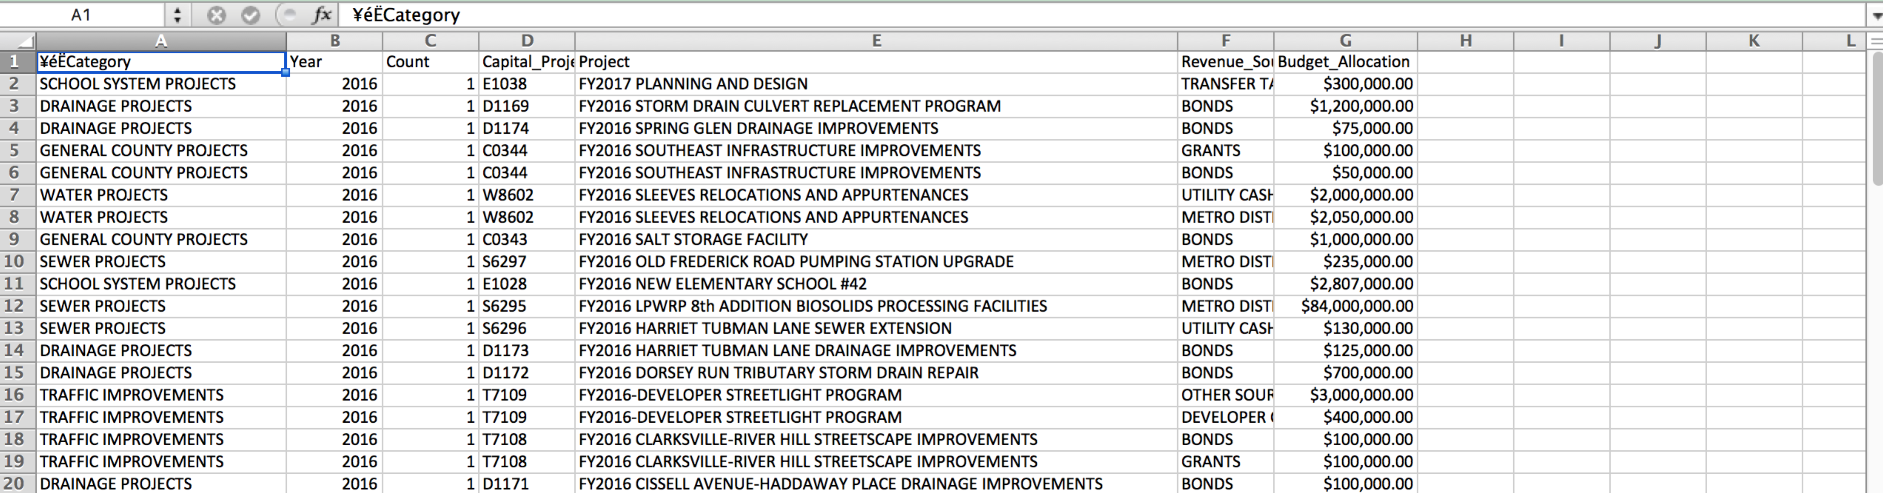

As we need only the Filter the category column by Police budget

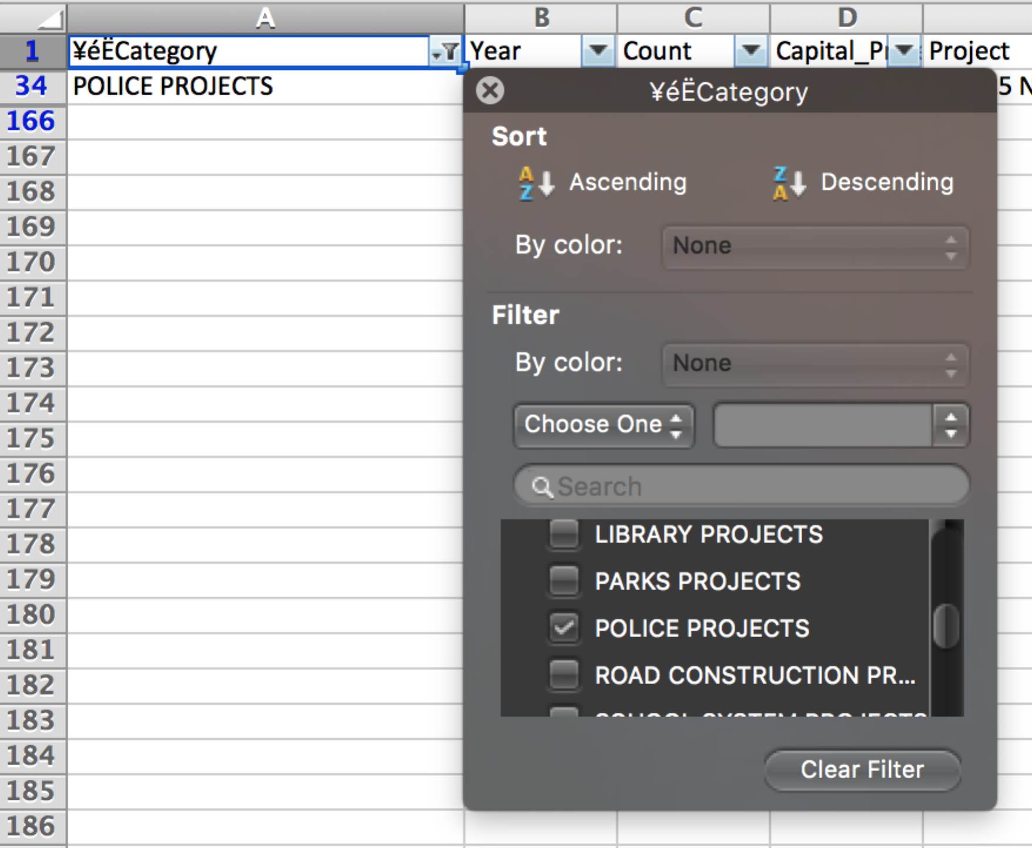

Now the dataset looks like



**Formatting first dataset:**

* **Dataset name**: Capital_Project_Expenditures_and_Budgets__FY_2015
* **Source Link**: (<https://opendata.howardcountymd.gov/Money-and-Finance/Capital-Project-Expenditures-and-Budgets-FY-2015/ghg6-4crr> )
* **Required formatting:** Only the project titled “New/Third police station” under the police projects budget category is needed for our analysis. So, the other rows should be filtered out appropriately.

Initially, the dataset looks like

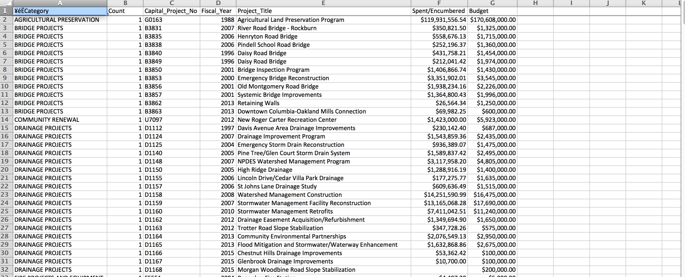

As we need only the Police budget, we should filter the category column by Police Projects

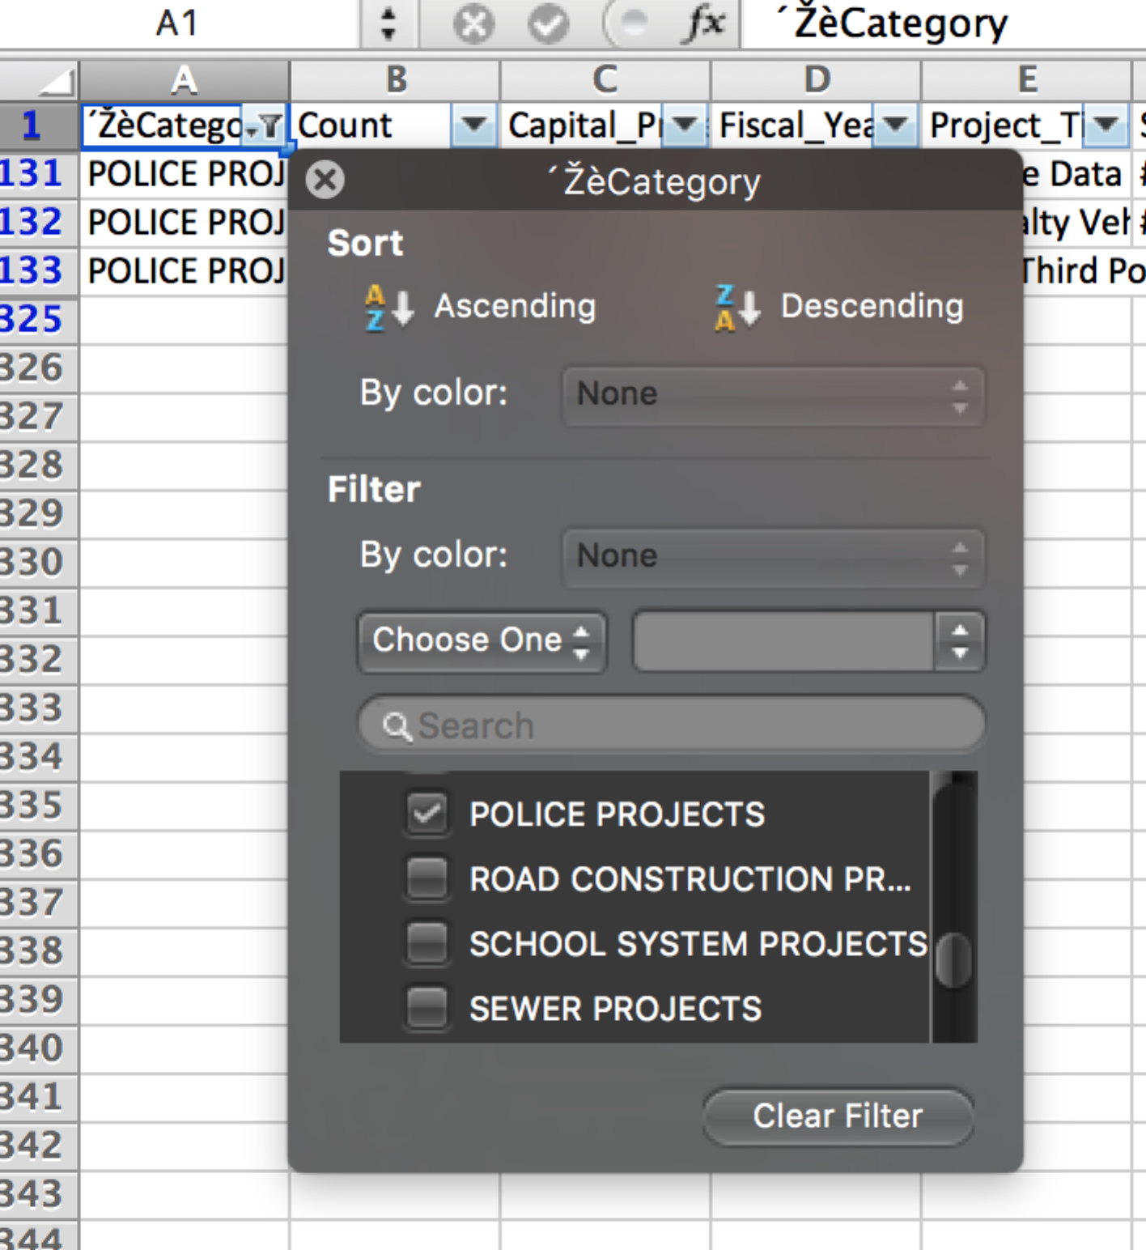

After applying filter, the dataset looks like

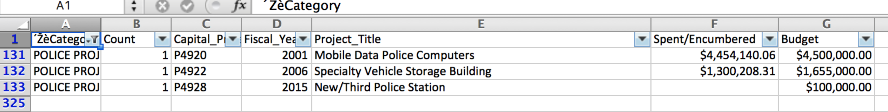

Among all the projects under police budget, we are considering only the “New/Third Police Station” project. So, the “Project_title” column should be filtered by the specific project.

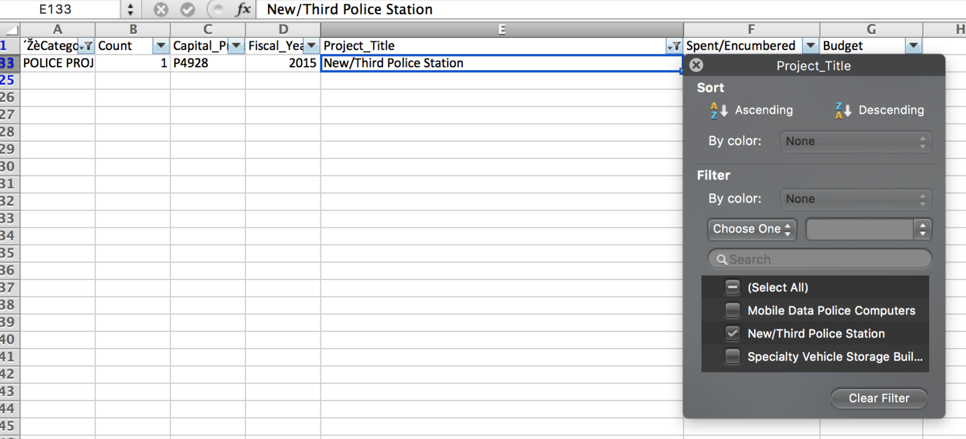

Now the final look of the dataset is



**Merging datasets:**

The following datasets are to be merged.

1. **Focal dataset** :- Capital_Project_Budget_Allocations__
2. **Dataset 2**:- FY2016Capital_Project_Expenditures_and_Budgets__FY_2015

In order to merge the datasets, each dataset should have a common column. The focal and second datasets have the below specified columns in common.

* Category
* Project_title
* Budget

After merging the two datasets using the common columns, the final merged dataset is

|  |  |  |  |
| --- | --- | --- | --- |
| **Year** | **Category** | **Project_title** | **Budget_Allocation** |
|  | - | - |  |
| 2015 | POLICE PROJECTS | FY2015 NEW/THIRD POLICE STATION | $100,000.00 |
| 2016 | POLICE PROJECTS | FY2015 NEW/THIRD POLICE STATION | $2,000,000.00 |
| Difference | - | - | $1,900,000.00 |